HOUSE PRICE PREDICTION USING MACHINE LEARNING

Internship Project Report

Intern Details
Intern Name : Kaniyamuthu B
Intern ID : CITS862
Internship Domain : Artificial Intelligence
Project Title : Fake News Detection Using
Machine Learning
Duration : 6 Weeks.

1. Abstract
House Price Prediction is a Machine Learning application that estimates the price of a house based on its features such as area and number of bedrooms. Accurate price prediction helps buyers, sellers, and real estate companies make informed decisions. This project uses a Linear Regression algorithm to predict house prices based on historical data.

2. Introduction
The real estate market is an important sector where property prices vary depending on several factors. Predicting house prices manually can be difficult and time-consuming. Machine Learning techniques can analyze housing data and estimate prices efficiently.
This project demonstrates how Linear Regression can be used to predict house prices using house features.

3. Objectives
- To develop a house price prediction system.
- To understand regression-based machine learning models.
- To predict house prices using property features.
- To demonstrate the practical use of Artificial Intelligence.
- To assist decision-making in the real estate domain.

4. Tools and Technologies Used
- Python
- Google Colab
- Pandas
- Scikit-Learn
- Linear Regression

5. Methodology

Step 1: Data Collection
A housing dataset containing area, number of bedrooms, and price was created.

Step 2: Data Preparation
The dataset was organized using a Pandas DataFrame.

Step 3: Feature Selection
The following features were used:
- Area (Square Feet)
- Number of Bedrooms

Step 4: Model Training
A Linear Regression model was trained using the dataset.

Step 5: Prediction
The model predicted house prices based on user-provided inputs.

6. Screenshots
Dataset Output:
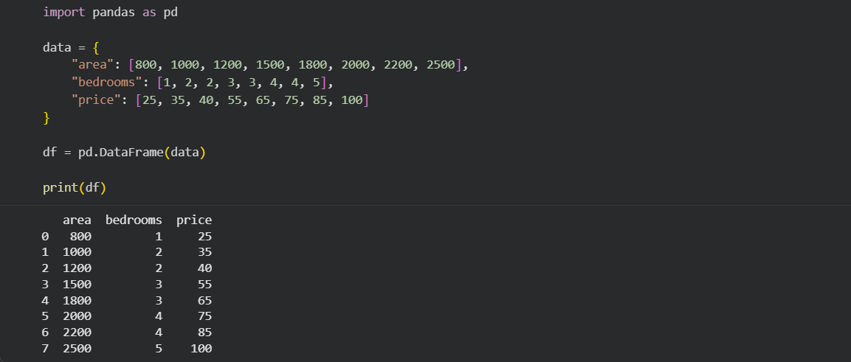

Model Training Output:

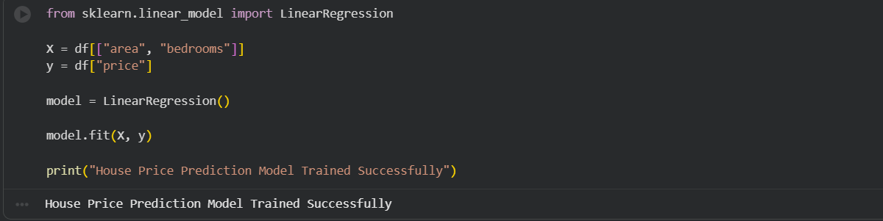
Prediction Example 1:
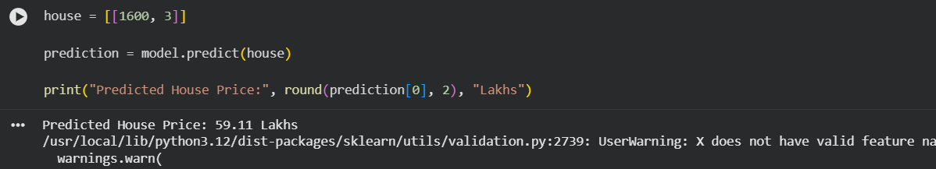
Prediction Example 2:
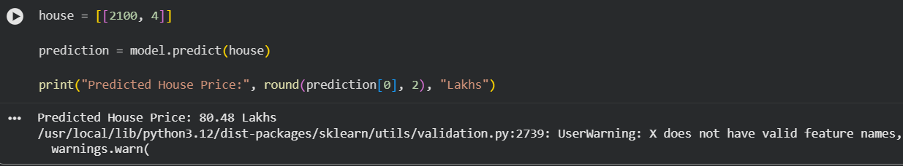
Interactive User Input Output:
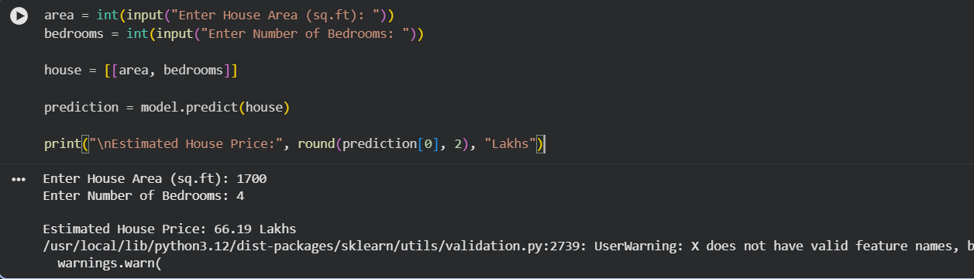
Project Completion Output:

7. Implementation
- Importing required libraries.
- Creating the dataset.
- Selecting input and output variables.
- Training the Linear Regression model.
- Predicting house prices.
- Displaying prediction results.

8. Future Enhancements
- Add location-based prediction.
- Include additional house features.
- Use larger real-world datasets.
- Develop a web application.
- Apply advanced machine learning models.

9. Conclusion
The House Price Prediction project successfully demonstrates the use of Machine Learning for estimating property prices. Using Linear Regression, the system predicts house prices based on area and number of bedrooms. This project highlights the practical applications of Artificial Intelligence in the real estate sector.

References
- Python Documentation
- Pandas Documentation
- Scikit-Learn Documentation
- Google Colab Documentation
- Machine Learning Fundamentals

